ASSIGNMENT ONE: COLOR WHEELS AND TEMPLATES – (5 pieces)

STATE STANDARD: Compose a value scale of black to white with eight levels of grey.

STATE STANDARD: Design and mix a color wheel with three primary colors.

STATE STANDARD: Show the secondary and intermediate colors and relationship to complimentary colors.

Students will create 5 different templates to demonstrate their understanding of color.
- Black, white and grey.
- Complimentary colors.
- Warm colors.
- Cool Colors.
- Primary Colors.

Students Will be Assessed on:
- Their ability to showcase their understanding of black, white and grey, complimentary and primary colors.
- Their ability to showcase their understanding of primary colors and the relationship these colors have to complimentary colors.

ASSIGNMENT TWO: BLACK AND WHITE STLL LIFE DRAWINGS – (5 pieces)

STATE STANDARD: Compose a contour line drawing of a still life with 5 mor more objects.

Anchor Standard 2 Organize and develop artistic ideas and work.

Students will create 5 individual black and white graphite pieces. These must be completed with pencil and demonstrate shading.

Students Will be Assessed on:
- Their ability to use of shading techniques with black, white and grey.
- Their ability to create a still life drawing.

ASSIGNMENT THREE: COLORED SURREALIST DRAWINGS – (3 pieces.)

Anchor Standard 2 Organize and develop artistic ideas and work.

Students Will be Assessed on:
- Their ability to use different colors to create personal pieces of art.
- Imagination and creativity.
- Ability to demonstrate surrealism in personal pieces.

ASSIGNMENT FOUR: POLITICAL CARTOONS – (Review 2 political cartoons.)

Students Will be Assessed on:
- their ability to identify the use of persuasive techniques and symbolism in political cartoons.
- .participation in a Summary and Wrap-up activity.
- their knowledge of history and background information in the process of interpreting political cartoons.

Student Outcomes (Exemplars):
1) Student is able to analyze and interpret a political cartoon found in newspapers, or a magazine.

Procedure:
Modern American political cartoons have been around since the nineteenth century. The increase in newspaper and magazine circulation in the 1800's provided a rich environment for the rise and use of political cartoons. Thomas Nast and Joseph Keppler penned many popular cartoons advocating social reform. People with minimal reading abilities could understand and relate to a format that communicated powerful ideas in a humorous, enlightened manner. Symbols, caricature, drawings, and exaggerations drawn by the cartoonist, point out the themes and problems of that historical era. Political cartoons play an important part in telling the history of a era.

Political cartoons serve to make people think about political and government issues by:

- providing readers with additional viewpoints
- assuming the reader has enough background knowledge about the issues to understand the message
- emphasizing one side of an issue or concern
- utilizing humor
- relying on drawings to make a point

Some of the benefits of using political cartoons in the classroom are that they can:

- promote interest in political issues
- help develop students' analytical thinking skills
- encourage creativity
- help prepare students for questions on the Social Studies Assessments and Regents Exams

Cartoonists use the following persuasive techniques to create humor:

symbolism - using an object to stand for an idea.
caricature - exaggerating a physical feature or habit: big nose, bushy eyebrows, large ears, baldness.
captioning and labels - used for clarity and emphasis.
analogy - a comparison between two unlike things that share some characteristics.
irony - the difference between the way things are and the way things should be or the way things are expected to be.
juxtaposition - positioning people or objects near each other, side-by-side.
exaggeration - overstating or magnifying a problem.

Symbols used in Political Cartoons

peace - dove, olive branch, victory sign.
United States - Uncle Sam, flag, stars and stripes, shield.
Democrats - donkey.
Republicans - elephant.
death - vulture, skeleton with shroud, skull and crossbones, grim reaper.
love - heart, Cupid, Venus.
money - dollar bill or dollar sign.
heroes or good guys - wear white.
villains or bad guys - wear black.

Analyzing the following two Political Cartoons and do the following

- Identify the characters, symbols and objects in the cartoon.
- Look for clues and details that provide further meaning.
- Identify the main idea of the cartoon by reading the captions and putting the message into their own words.
- Identify any bias the cartoonist might have.

Questions

- What is the event or issue that inspired the cartoons? Check the dates and do a bit of research for this one…
- What background knowledge do you need to understand the message?
- Are there any real people in the cartoon?
- Did the artist use caricatures, (over-dramatic cartoons of people)
- Are these symbols in the cartoons?
- What is the cartoonist's opinion about the topic portrayed?
- Does the caption help you understand the message?
- Do you agree or disagree with the cartoonists option? Why?

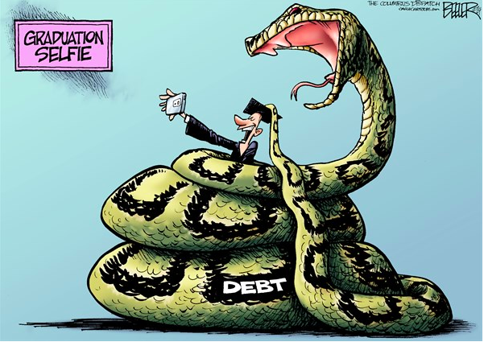

AMERICA 2015 ABOVE &
THE 13 ORIGINAL COLONIES 1776 BELOW
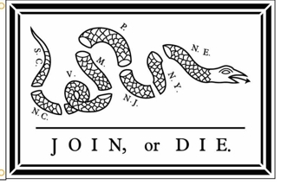

ASSIGNMENT FIVE: Visit to an Art Museum

Anchor Standard 9 Apply criteria to evaluate artistic work.

For this task, you will visit a local art museum. You may choose to go to Tacoma Art Museum, Seattle Asian Art Museum, or Seattle Art Museum. There are also several museums in Portland, Oregon. This is not an exhaustive list, other museums may be selected with Tate’s approval.

Reflection: You will write a 5-7 paragraph essay describing your experience. Describe the actual building. What did it look and sound like? How many people were there? How was the art displayed?

You will also include your feelings regarding the art. Which pieces were your favorite? Why? What artistic techniques did you recognize? What famous art, or work by famous artists did you see?

Choose one piece. What qualities of the artwork do you think work well? What qualities seem not to work and why? What would you change to make it work better? ← Can you compare it with a similar artwork that you liked or didn’t like? ← What criteria can you list to help others judge this work? ← How original or creative is the work?

Students Will be Assessed on:.
- Effort and level of participation.
- Description of the surroundings and experience.
- Ability to recognize artistic techniques in real-life pieces.

ASSIGNMENT SIX: Photo ESSAY

Anchor Standard 10 Synthesize and relate knowledge and personal experiences to make art.

A photo essay is a collection of photos that are placed in a specific order to a story.

The first step will be to choose a topic or subject. Chose something that interests you. You will need to include 7-10 photographs that convey emotion to tell a unique story. Chose your photos carefully. If you are telling the story of global warming, chose photos that show the changes our planet is going through. If you are telling the story of your new puppy, choose photos that show his physical and emotional growth. The best way you can connect your photo essay with its audience is to draw out the emotions within the story and utilize them in your shots. This does not mean that you manipulate your audience’s emotions. You merely use emotion as a connecting point.
Then, put your pictures in a specific order.

Students Will be Assessed on:
- Their ability select photos that contain emotion.
- Their ability to tell a story using images.
- Effort and level of participation.

ASSIGNMENT SEVEN: ABSTRACT PAINTING – (Final project.)

Student will create an abstract painting based on techniques studied in the course. Students will demonstrate knowledge of color. Painting can be any size, but should be larger than 9X11 inches.

Students Will be Assessed on:
- Their ability to use water color or acrylic effectively.
- Their portrayal of abstract techniques.
- Effort and level of participation.

